Worksheet 2: Working with timber

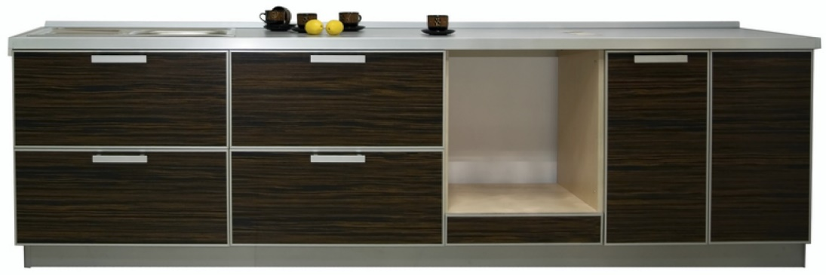**Task 1**

Kitchen cabinet manufacturers frequently use standard components and knock down fittings to enable their cabinets to be assembled in situ.

Look closely at the image above:

What wood fixing could you use to attach a worktop to the cabinet carcass?

Reason for choice

What type of hinge could you use to hang the doors on the cabinet carcass?

Reason for choice

What fixing would you use to connect a hinge to a cabinet door?

Reason for choice

**Mathematics extension exercise**

One unit carcase measuring 600mm wide and 560mm deep and 720mm high is to be cut and fabricated from a sheet of chipboard. Using the cutting specification below, show how the parts would fit efficiently onto a standard sheet 1220mm x 2440mm.

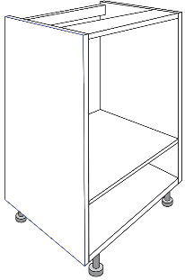

2 x 560mm x 500mm

2 x 720mm x 560mm

2 x 560mm x 100mm

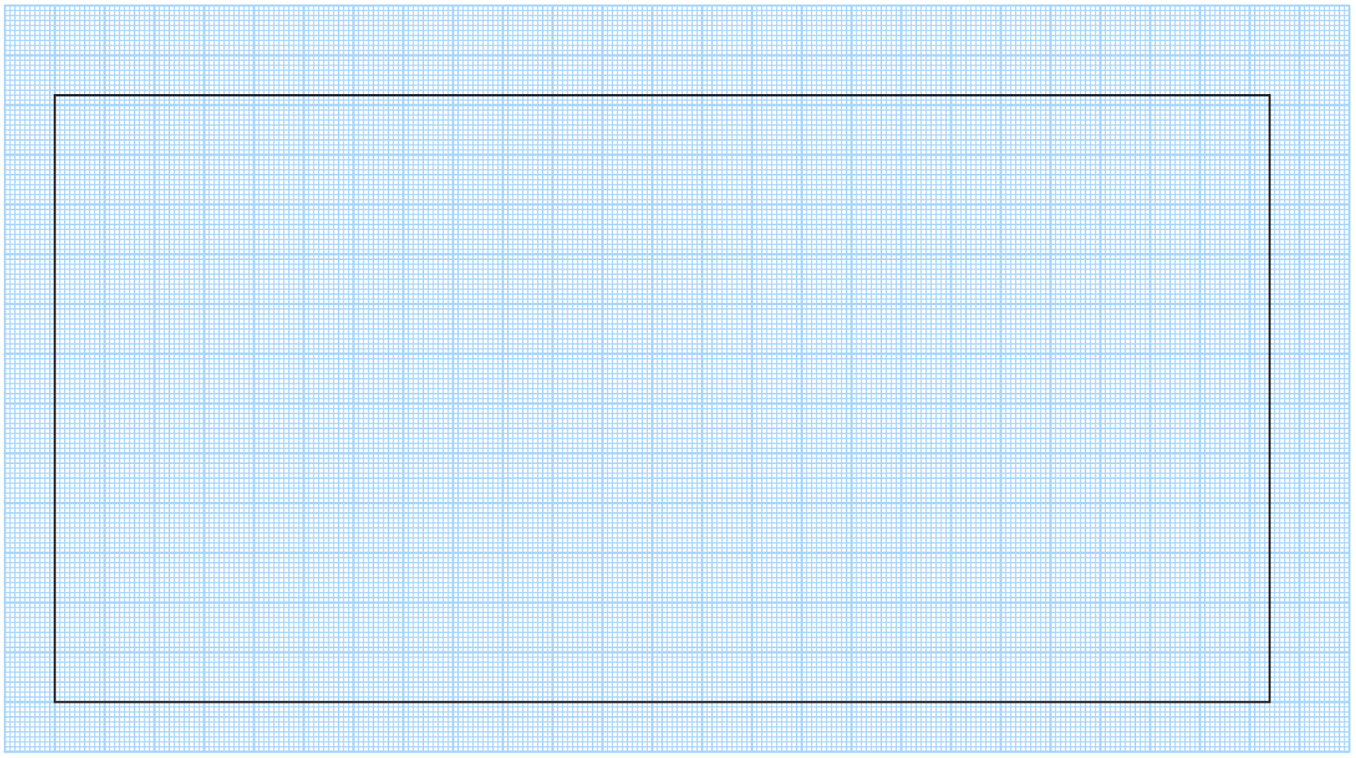

Calculate the area of waste material. (You can assume there is no allowance for kerf.)

Is it theoretically possible to cut two carcases from the same piece of board?

Is it physically possible?

**Task 2**

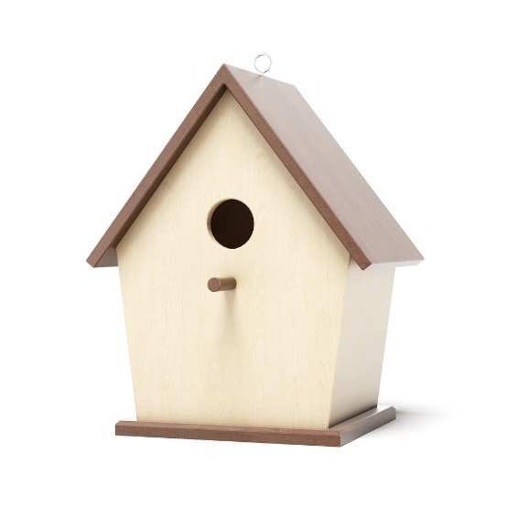

Look closely at the image above:

**Point 1** - What type of joint has been used to join the two pieces that make the peak of the roof?

Reason for choice

**Point 2** – The roof is screwed to the body of the box, what is the name of the **first** hole that is drilled through both pieces of wood to accommodate the screw?

What is the name of the **second** larger hole that is drilled through the top piece of wood only?

What is the name of the drill bit that is used to make a third shallow hole that allows the head of the screw to sit flush against the wooden roof?

**Point 3** - What type of drill bit would you use to create the entrance hole in the front of the bird box?

What type of sander might help you sand the inside of the hole to ensure a smooth surface?

**Sketching extension exercise**

**Point 4** – The box appears to be butt jointed to the base, what similar type of joint would ensure better location and greater strength than a butt joint alone?

Reason for choice

In the space below, draw an exploded view of the dowelled joint that joins the box to the base.

|  |
| --- |
|  |

**Task 3**

Describe, using sketches and annotations, how you would laminate the wooden chair

component pictured below.

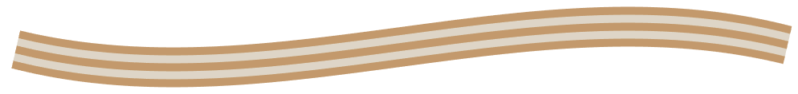

|  |
| --- |
|  |

What are the advantages of laminated timber over single timber planks or boards?