Worksheet 1: Sources, origins and properties

**Task 1**

A European company that designs and manufactures wooden kit houses like the one below has asked you to source materials for the construction of similar houses in the UK.

All materials must be sustainably sourced and be either recyclable or made of recycled materials.

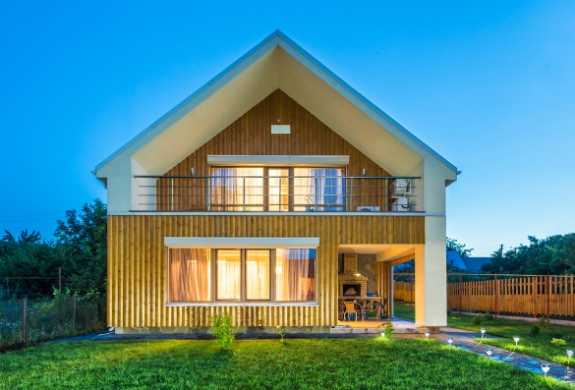

Suggest a suitable material and its source for the external frame of the house and the window and door frames:

**Material:**

**Reason for choice:**

**Source of material:**

Carbon is produced with every mile timber travels, and with every process that it goes through. Describe how each stage of timber production from tree to end product adds to its overall carbon output.

The house builders also design internal fixtures and furniture for the houses. On the whole, they prefer to use solid timber. How would you suggest they season the timber for this?

**Method of seasoning:**

**What moisture content should this be seasoned to?**

**What is the reason for your answer?**

**Task 2**

Suggest a suitable timber based material that could be used internally to form the floors.

**Material:**

**Reason for choice:**

**Source of material:**

The company is also considering designing a garden storage shed for the house. Explain why you **would not** choose to make this out of chipboard?