Worksheet 1: Sources, origins and properties

**Task 1**

What happens in the distillation tower of an oil refinery? Complete the table below using the diagram and sentences below to help prompt you

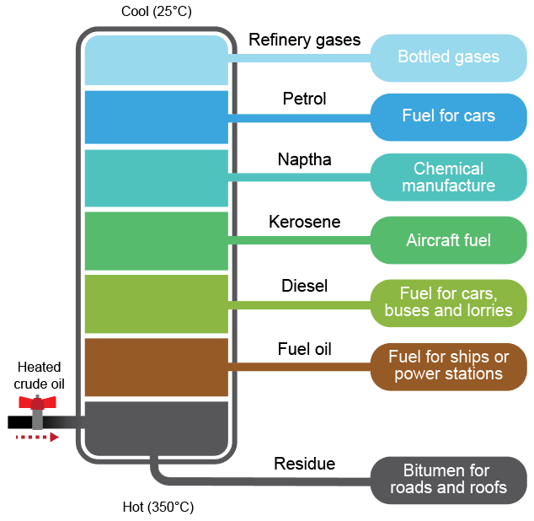

Put the following in the correct order:

* As the crude oil cools, the molecules condense
* The fractions (hydrocarbons) are siphoned off for cracking
* Hot oil is pumped into the base of the distillation tower
* Heavier molecules stay at the bottom and lighter molecules are at top
* The crude oil vaporises and rises up the tower

|  |  |  |  |  |  |
| --- | --- | --- | --- | --- | --- |
| **Stage 1** | **Stage 2** | **Stage 3** | **Stage 4** | **Stage 5** | **Stage 6** |
|  |  |  |  |  |  |

* Crude oil is heated to 350 degrees C

**Task 2**

Watch the video on the Life Cycle of plastic bottles.

Write down the two missing potential end scenarios for plastic, and note down any positive or negative impacts on the environment for all three.

|  |  |  |
| --- | --- | --- |
| **Life Cycle 1 –** | **Life Cycle 2 –** | **Life Cycle 3 – Recycling** |
| C:\Users\Rob\AppData\Roaming\PixelMetrics\CaptureWiz\Temp\45.png | C:\Users\Rob\AppData\Roaming\PixelMetrics\CaptureWiz\Temp\47.png | C:\Users\Rob\AppData\Roaming\PixelMetrics\CaptureWiz\Temp\46.png |
|  |  |  |
| **Negatives:** | **Negatives:** | **Negatives:** |
| **Positives:** |

**Task 3**

Look at the two products pictured here, A and B.

**Product A Product B**

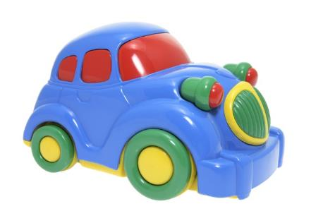 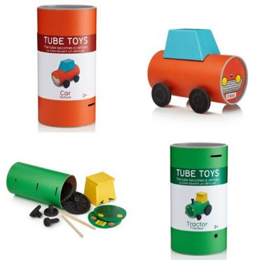

1. Discuss the possible environmental impact of using plastic made from a petrochemical source to manufacture product A.

Include information from sourcing the raw material to the end of the product’s life cycle.

1. Tube Toys are a series of vehicles where the packaging is also part of the product. The materials used include cardboard, rubber, bamboo and LDPE for the wheels.

Why is Product B more sustainable?