Worksheet 2: Working with polymers

**Task 1 Stock forms types and sizes**

Calculate suitable the sizes and forms of material required to make the desk tidy shown. Justify suitable thicknesses appropriate for use.

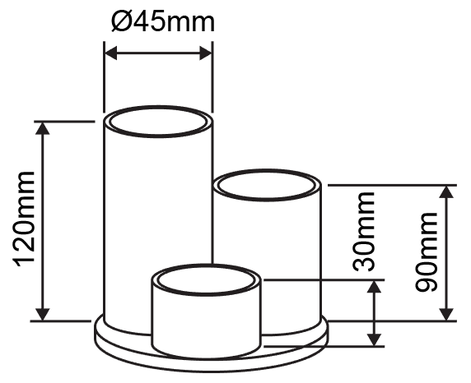

**Task 2**

Name the type of screw heads pictured below. Sketch out **two** other different screw heads that you discover.

|  |  |  |  |  |
| --- | --- | --- | --- | --- |
|  |  |  |  |  |
|  |  |  |  |  |

Look at the images in the table below. Fill in the missing boxes to suggest which hinge types would be most suitable for each use and justify your reasons.

|  |  |  |
| --- | --- | --- |
| **Image** | **Hinge type** | **Justification** |
| Acrylic screen on an advertising billboard |  |  |
| Tool box |  |  |
| Cosmetics case |  |  |

**Task 3**

Featured below are three of saws used to cut plastic.

Name each saw. Explain one feature of, or advantage to using each saw   
for cutting plastic.

|  |  |  |
| --- | --- | --- |
| **Name** | **Saw** | **Advantages** |
|  |  |  |
|  |  |  |
|  |  |  |

**Task 4**

This display stand requires line bending. Put the stages listed for the process of making it in the correct order. The first one has been done for you.

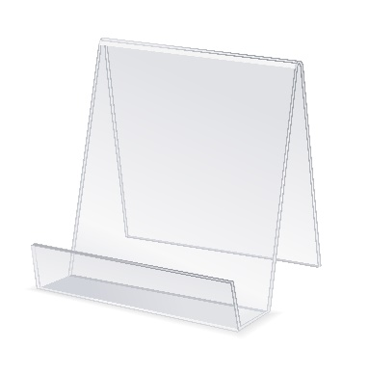

|  |  |
| --- | --- |
| **Correct order** | **Stage** |
| 1 | Use a chinagraph pencil to mark out where the bend lines should be |
|  | Place the marked line of the workpiece across the heating strip |
|  | Turn on the strip heater so that it comes up to a working temperature |
|  | Allow the plastic to heat through |
|  | Bend the workpiece to the required angle and repeat for other bends |
|  | Once the workpiece has set it can be cooled in the water tray |
|  | Put on heat-proof gloves and have a tray of water ready to cool the workpiece |
|  | Test for flexibility as the workpiece approaches the right temperature |

What two safety precautions could you take when line bending?

**Task 5**

When vacuum forming, a mould should conform to various properties to ensure there are no issues covered by points A, B and C below.

1. **To ensure easy removal of the mould**
2. **To ensure the plastic is not drawn too thin and breaks**
3. **To avoid air pockets**

State which of A, B or C, each of the properties below aim to resolve.

* A positive draft angle of at least 3° –
* No undercuts –
* A profile that is not too deep –
* Vent holes drilled –
* Corners and edges rounded with a small radius –
* A smooth finish and a release agent can be applied to the mould –

**Task 6**

Describe how 3D printed objects are created using fused deposit modelling (FDM)?

What advantages are there to 3D printing a prosthetic arm?