Worksheet 3: Manufacture and finishing

**Task 1**

Shown below is a plastic planter which could be used as a window box or patio garden.



What factors would the designer and manufacturer need to consider before choosing the most appropriate plastic for the planter? Think of at least **five** different factors.

Based on your answers, justify whether it would be appropriate to use a thermosetting plastic or thermoplastic to create the planter.

**Task 2**

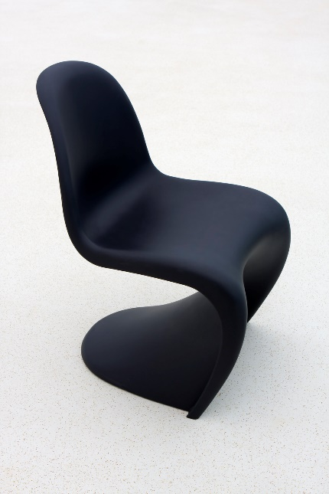

*Figure 1: Panton chair*

Figure 1 shows the popular Panton ‘S’ shaped chair, first designed in 1960 by the Danish designer Verner Panton.

It is made by injection moulding polypropylene reinforced with fibreglass. What advantages are there to choosing injection moulding for manufacturing this chair?

What are the drawbacks of injection moulding objects with a small production run?

**Task 3**

Outline three advantages of using a laser cutter at school for cutting out 10 of the same shaped clock bodies from acrylic sheet rather than cutting them by hand using a coping saw.

Justify your points where possible.

**Task 4**

Quality control checks are carried out on a product as it is made. These help to ensure that each product meets a specific standard.

Discuss what sort of checks might be important to carry out on the flat pack desk pictured below.

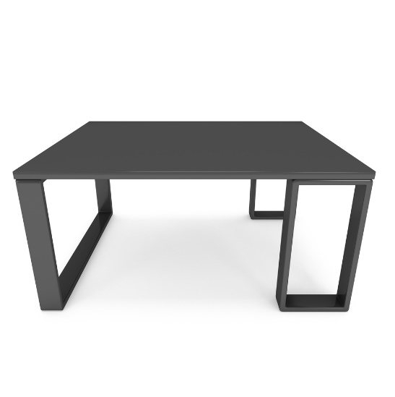

Why is it important to carry out these quality control checks?

**Task 5 Extension**

The picture below shows a toy that allows young children to develop and learn via exploring and interacting with their environment.

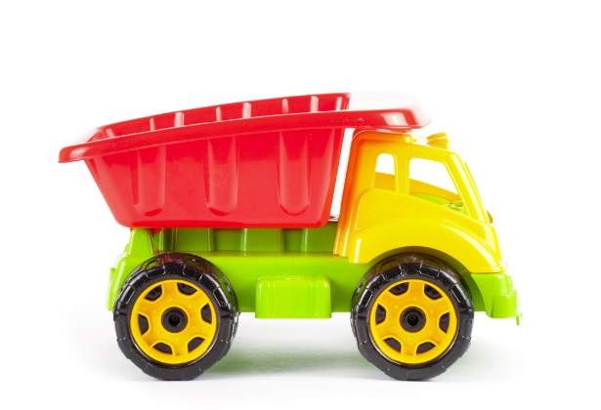

HDPE has been used **for the manufacture of the car parts.** Explain **two** reasons why HDPE would be suitable.

Describe the injection moulding process, using notes and diagrams/sketches.

Outline the advantages of injection moulding. Consider initial capital investment, tooling, accuracy, quality control and quantity of product.