Worksheet 3: Manufacturing and finishing

**Task 1**

The two commercially produced benches below are very similar in design however the bench in *figure 1* is made from the softwood pine and the bench in *figure 2* is made from the hardwood oak.

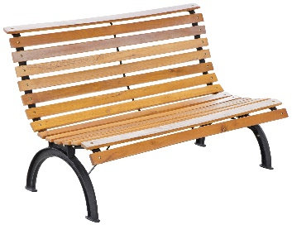 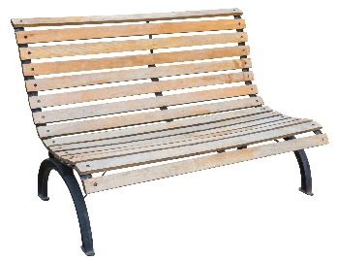

*Figure 1 Figure 2*

State **two** advantages of using pine to manufacture this bench?

Name **one** disadvantage of using pine.

List **two** advantages of using oak to manufacture this bench?

List **one** disadvantage of using oak.

**Task 2**

The billiard table is made from natural timber.

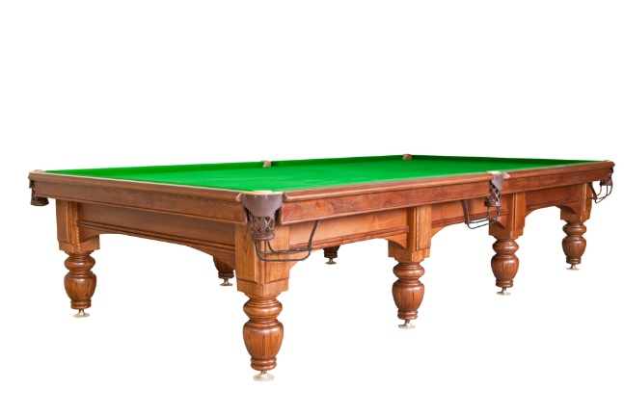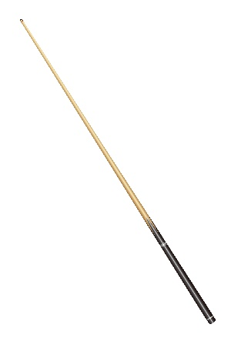

Suggest suitable commercial manufacturing techniques for finishing the detail on the sides of the table, and for producing the legs and the cue.

Reason for choice:

What would be a suitable method of finishing and protecting the table?

Reason for choice:

**Extension task**

The wooden clock has been commercially made.

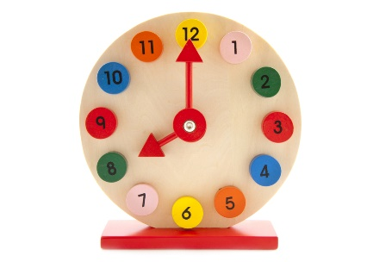

Why do you think that bright colours have been used for the numbers and hands on   
this clock?

What are the risks of using paint on a child's toy?

What can the manufacturer do to ensure the clock is safe?

**Task 3**

Manufactured board is often used in the production of flat pack furniture.

Give **two** advantages and **two** disadvantages of using manufactured board instead of a natural timber.

|  |  |
| --- | --- |
| **Advantages** | **Disadvantages** |
|  |  |
|  |  |