Seaford College

A Level French

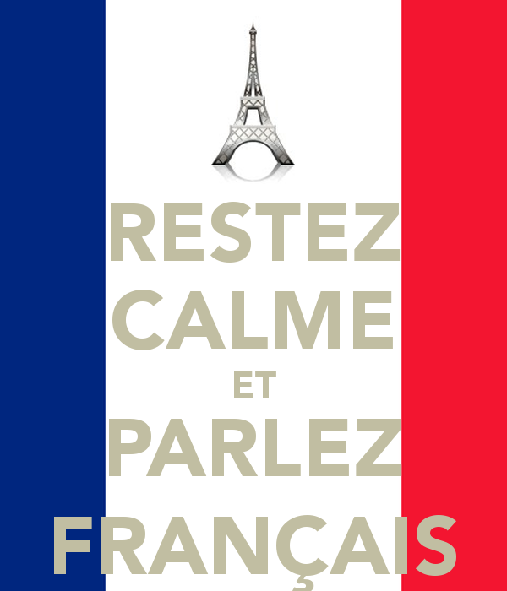



Welcome to the French A Level! This handbook is your reference guide to the course requirements and expectations of you as a student on this two-year EDEXCEL-examined course.

**Structure of the course and format of the exam:**

This is a two year course.

**Subject Content**

Students study all the following themes on which the assessments are based:

**Thème 1: Les changements dans la société française**

Theme 1 is set in the context of France only. This theme covers social issues and trends.

● **Les changements dans les structures familiales**

* Les changements dans les attitudes envers le mariage, les couples et la famille.

● **L’éducation**

* Le système éducatif et les questions estudiantines.

● **Le monde du travail**

* La vie active en France et les attitudes envers le travail; le droit à la grève; l’égalité des sexes.

**Thème 2: La culture politique et artistique dans les pays Francophones**

Theme 2 is set in the context of francophone countries and communities. This theme covers artistic culture (through music and festivals and traditions) and political and artistic culture (through media).

● **La musique**

* Les changements et les développements; l’impact de la musique sur la culture populaire.

● **Les médias**

* La liberté d’expression; la presse écrite et en ligne; l’impact sur la société et la politique.

● **Les festivals et les traditions**

* Les festivals, fêtes, coutumes et traditions.

**Thème 3: L’immigration et la société multiculturelle française**

Theme 3 is set in the context of France only. This theme covers social issues and trends.

● **L’impact positif de l’immigration sur la société française**

* Les contributions des immigrés à l’économie et à la culture.

● **Répondre aux défis de l’immigration et l’intégration en France**

* Les activités des communautés; la marginalisation et l’aliénation du point de vue des immigrés.

● **L’extrême droite**

* La montée du Front National; les leaders du Front National; l’opinion publique.

**Thème 4: L’Occupation et la Résistance**

Theme 4 is set in the context of France only. This theme covers political culture.

● **La France occupée**

* La collaboration; l’antisémitisme.

● **Le régime de Vichy**

* Maréchal Pétain et la Révolution nationale.

● **La Résistance**

* Jean Moulin, Charles de Gaulle et les femmes de la Résistance; la résistance des français.

**Assessments**

The A Level consists of two externally examined papers assessing listening, reading and writing as well as a non-examined speaking assessment. Students must complete their speaking assessment in April/May and all other assessments in May/June.

**Paper 1: Listening, reading and translation:**

|  |
| --- |
| **What’s assessed**  This paper draws on vocabulary and structures across all four themes. |
| **How it’s assessed**   * Written examination 2 hours * 80 marks * 40% of A Level |
| **Questions**   * Section A: Listening. (30 marks) * Section B: Reading (30 marks) * Section 3: Translation into English. (20 marks) |

**Paper 2: Written response to works and translations.**

|  |
| --- |
| **What’s assessed**  This paper draws on the study of two French works: either two literary texts or one literary text and one film. (Appendix 1) |
| **How it’s assessed**   * 2 hours and 40 minutes * 120 marks * 30% of A Level |
| **Questions**   * Section A: Translation (20 marks) English to French. * Section B: Written response to literary texts. (50 marks) * Section C: Written response to films. (50 marks) |

**Paper 3: Speaking**

|  |
| --- |
| **What’s assessed**  Students will be assessed on their ability to use a range of language accurately, communicate and interact effectively, summarise and analyse findings from written sources relating to their research subject, and show knowledge and understanding about the culture and society where the language is spoken |
| **How it’s assessed**   * Between 16 to 18 minutes, plus 5 minutes preparation time * 72 marks * 30% of A Level |
| **Questions**   * Task 1: (6 to 7 minutes / 30 marks) discussion on a Theme. Based on a sub-theme. Students will be able to choose one out of two sub-themes. Stimulus card will be given as a springboard to the discussion. * Task 2 (10 – 11 minutes / 42 marks) part 1: presentation on student’s independent research project * Task 2, Part 2 discussion on independent research |

**Appendix 1: Prescribed literary texts and films**

For *Paper 2*, students are required to study two works from the list below. This can be either two literary texts **or** one literary text and one film.

**Literary texts**

● *Boule de Suif et autres contes de guerre (Boule de Suif, Un Duel, Deux Amis, La Mère Sauvage*), Guy de Maupassant, 1880 (short stories)

● *La Place,* Annie Ernaux, 1983 (novel)

● *Le Blé en Herbe,* Colette, 1923 (novel)

● *Le Château de ma Mère,* Marcel Pagnol, 1957 (novel)

● *Le Gone du Chaâba,* Azouz Begag, 2005 (novel)

● *Les Mains Sales,* Jean-Paul Sartre, 1948 (play)

● *Les Petits Enfants du siècle,* Christiane Rochefort, 1961 (novel)

● *Le Tartuffe,* Molière, 1669 (play)

● *L’Étranger,* Albert Camus, 1942 (novel)

● *No et Moi,* Delphine de Vigan, 2007 (novel)

● *Thérèse Desqueyroux,* François Mauriac, 1927 (novel)

● *Une si longue lettre,* Mariama Bâ, 1981 (novel)

*Un Sac de Billes,* Joseph Joffo, 1973 (novel)

**Films**

● *Au Revoir les Enfants,* dir. Louis Malle (1987)

● *Chocolat,* dir. Claire Denis (1988)

● *Cléo de 5 à 7,* dir. Agnès Varda (1962)

● *Deux Jours, une Nuit,* dirs. Jean-Pierre Dardenne, Luc Dardenne (2014)

● *Entre les murs,* dir. Laurent Cantet (2008)

● *Intouchables,* dirs. Oliver Nakache, Eric Toledano (2011)

● *La Haine,* dir. Mathieu Kassovitz (1995)

● *La Vie en Rose,* dir. Olivier Dahan (2007)

● *Le Dernier Métro*, dir. Françöis Truffaut (1980)

● *Les Choristes,* dir. Christophe Barratier (2004)

● *Les 400 Coups,* dir. Françöis Truffaut (1959)

● *Un Long Dimanche de Fiançailles,* dir. Jean-Pierre Jeunet (2004)

**Grammar list**

**Nouns**

● Gender

● Singular and plural forms

**Articles**

● Definite, indefinite and partitive

**Adjectives**

● Agreement

● Position

● Comparative and superlative

● Use of adjectives as nouns (e.g. le vieux, les Anglais)

● Demonstrative (ce, cet, cette, ces)

*● Indefinite (including autre, chaque, même, quelque)*

● Possessive (mon, ma, mes, etc.)

● Interrogative and exclamatory (quel, quelle, quels, quelles)

**Numerals**

● Cardinal (e.g. un, deux)

● Ordinal (e.g. premier, deuxième)

● Expression of time and date

**Adverbs**

● Formation of adverbs in –ment

● Comparative and superlative

*● Interrogative (including combien (de), comment, où, pourquoi, quand)*

**Quantifiers/intensifiers**

*● Including assez, beaucoup, moins, plus, la plupart, plusieurs, presque, tant, très, l trop*

**Pronouns**

● Personal: subject, including on

● Object: direct and indirect

● Disjunctive/emphatic personal, as subject and object: moi/moi-même, etc.

● Position and order

● Reflexive

*● Relative (including qui, que, dont, lequel etc., auquel etc., ce qui, ce que)*

*● Demonstrative (celui, celle, ceux, celles; and celui-ci/celui-là etc.)*

● Indefinite (including quelqu’un, quelque chose)

● Possessive (le mien etc.)

● Interrogative (including qui, que, quoi)

● Use of y, en

**Verbs**

● Conjugation of regular -er, -ir, -re verbs, modal verbs, principal irregular verbs, including reflexive verbs

● Agreement of verb and subject

● Use of il y a

● Modes of address (tu, vous)

● Impersonal verbs

● Constructions with verbs

o Verbs followed by an infinitive (with or without a preposition)

● Dependent infinitives (faire réparer) (R)

● Perfect infinitive

● Negative forms

● Interrogative forms

● Use of tenses

o present

o perfect (including agreement of past participle)

o imperfect

o future

o conditional

o future perfect

o conditional perfect

o pluperfect

o past historic (R)

● Verbal paraphrases and their uses (including aller + infinitive, venir de + infinitive)

● Passive voice

o present tense

o other tenses (R)

● Dependent infinitives (faire réparer)

● Passive voice: all tenses

● Subjunctive mood:

o present (common uses, for example, after expressions of possibility, necessity, obligation and after conjunctions such as bien que)

o perfect tense

o imperfect tense (R)

**Prepositions**

● All prepositions, both simple (e.g. sous) and complex (e.g. au-delà de)

**Conjunctions**

● Coordinating conjunctions (e.g. et, ou, mais)

● Subordinating conjunctions

**Negation**

*● Use of negative particles (e.g. ne...pas, ne...personne, ne...que)*

● Use of ne with negative subjects (e.g. Personne n’est venu)

**Questions**

**Commands**

**Word order**

● Inversion after speech

● Inversion after adverbs

**Other constructions**

● Time expressions with depuis and il y a

● Comparative constructions

● Indirect speech

**Discourse markers**

*● e.g. Au contraire, En fait*

**Fillers**

*● e.g. alors, bon*

**Our expectations of you!**

1. Good attendance to lessons.
2. Catching up on work missed through absence.
3. A willingness to be responsive and pro-active in class.
4. A readiness to participate fully in class speaking tasks.
5. To record and learn vocabulary without being instructed to do so.
6. To record grammar notes accurately, re-read through notes and apply new grammar to your writing.
7. A desire to enhance your language-learning through wider reading and listening to French radio, news and watching French films and TV.
8. A willingness to use the resources available to you and to actively participate in all the lessons.
9. To use a dictionary suited to A Level study (Oxford or Collins).
10. A firm commitment to regular independent study.