**The Development of the atom model:**

**Have a watch:**

**https://www.youtube.com/watch?v=g5oqg_LiXuY**

**https://www.youtube.com/watch?v=kBgIMRV895w**

**https://www.youtube.com/watch?v=GhAn8xZQ-d8**

**The Greeks: - not just producers of fine olives and goat’s cheese.**

Over 2000 years ago the Greeks thought the smallest thing possible was the **atom**.

In Greek this word means…………….

Draw a representation of an atom and label it “atom”.

2000 years later after the crazy Europeans stopped fighting each other for a little while we got through the “Dark ages” and the “renaissance” (the age of rethinking old ideas) and starting thinking.

The Greeks theory about the “atom” – the smallest building block of matter (stuff) was thought about and some daring souls in the 20th century started to do strange experiments.

**Step forward Mr J. J. Thompson:**

Mr J.J. Thonpson experimented with a cathode ray tube and came up with this model of the atom:

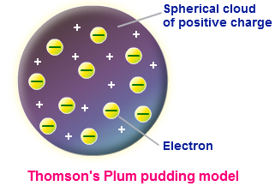

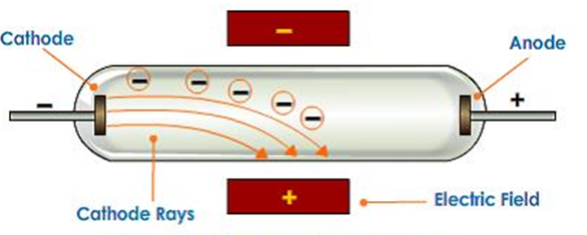

**J. J. Thompson proved the existence of the electron.**

**Describe / explain how his experiment proved the existence of electrons and how he knew they had a negative (-) electric charge:**

**He had evidence for electrons and that they were negatively electric charged. How did he come to his conclusions about the rest of the atom?**

**Why was this model called the “Plum pudding” model? What were the single plums in this model and what was the sticky cake?**

**Step forward Mr Thompson’s Padawan – Ernst Rutherford:**

After making his own lightsabre, Rutherford did his own fascinating experiments on the atom and his results were very interesting:

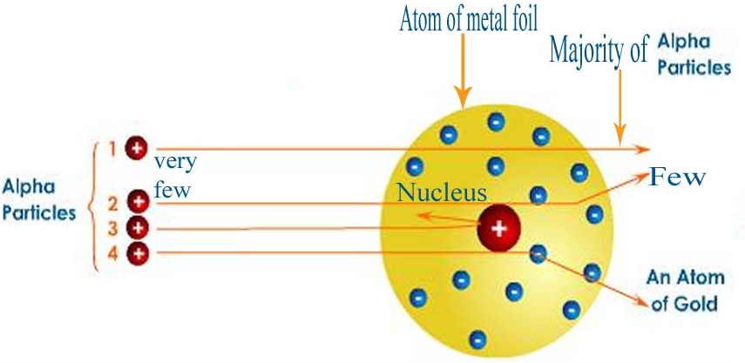

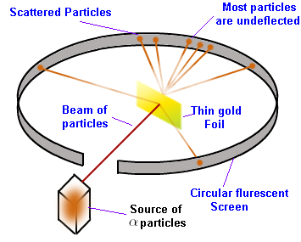

Rutherford came out with a new model of the atom called the “**Nuclear**” or **centre** model.

**Explain what he did in his experiment:**

**What happened to the positively (+) charged alpha radiation particles he fired at gold atoms:**

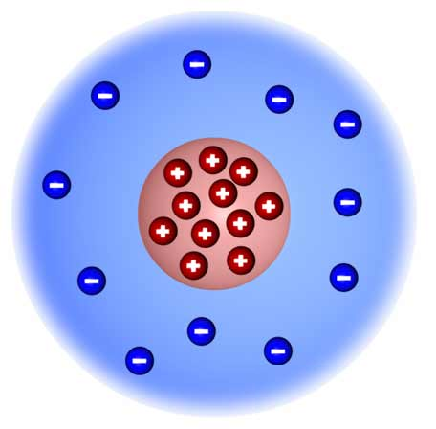

**What conclusion did he come to:**

**Niels Bohr – Danish Viking and mathematician:**

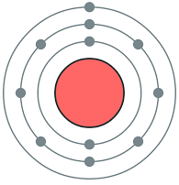

Niels Bohr made a slight change to Rutherford’s model.

He came up with a mathematical model / theory about the atom and when scientists

did experiments to prove or disprove his theory or model, they proved it correct.

Niels Bohr’s mathematical model of the atom suggests that…..

Explain / describe why he changed the model to put the electrons in certain orbits

at different distances around the nucleus.

**The mysterious neutron!!!!!**

The neutron was the last sub-atomic particle to be discovered.

Describe how it was discovered and why it was difficult to observe / discover.

**See you in September – have a good holiday.**