Seaford College

A Level Spanish

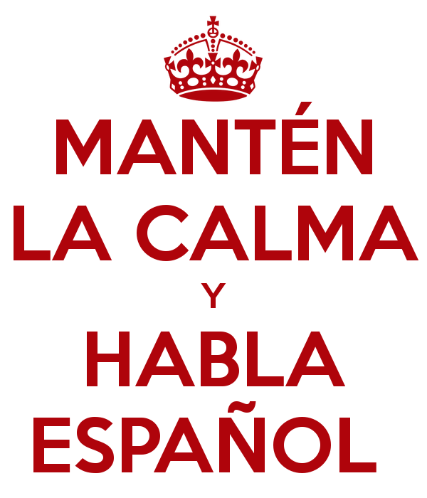





Welcome to the Spanish GCSE! This handbook is your reference guide to the course requirements and expectations of you as a students on this two-year EDEXCEL-examined course.

**Structure of the course and format of the exam:**

This is a two-year course.

**Subject Content**

Students study all the following themes on which the assessments are based:

* Theme 1: La evolución de la sociedad española.
* Cambio de la estructura familiar
* El mundo laboral
* El impacto turístico en España
* Theme 2: La cultura política y artística en el mundo de habla española
* La música
* Los medios de comunicación
* Los festivales y las tradiciones
* Theme 3: La inmigración y la sociedad multicultural española
* La inmigración históricamente y contemporáneamente
* La integración y el multiculturalismo.
* Theme 4: La dictadura franquista y la transición a la democracia
* La dictadura franquista
* El paso de la dictadura a la democracia

**Assessments**

The A Level consist of two externally-examined paper assessing listening, reading and writing. And a non-examined speaking assessment. Students must complete their speaking assessment in April/May and all other assessment in May/June.

**Paper 1. Listening, reading and translation:**

|  |
| --- |
| **What’s assessed**  This paper draws on vocabulary and structures across all four themes. |
| **How it’s assessed**   * Written examination 2 hours * 80 marks * 40% of A Level |
| **Questions**   * Section A: Listening. (30 marks) * Section B: Reading (30 marks) * Section C: Translation (Spanish to English) (20 marks) |

**Paper 2: Written response to works and translations.**

|  |
| --- |
| **What’s assessed**  This paper draws on the study of two Spanish works: either two literary texts or one literary text and one film. (Appendix 1) |
| **How it’s assessed**   * 2 hours and 40 minutes * 120 marks * 30% of A Level |
| **Questions**   * Section A: Translation (20 marks) English to Spanish. * Section B: Written response to literary texts. (Either one or two) (50 marks) * Section C: Written response to films. (Either one or none) (50 marks) |

**Paper 3: Speaking**

|  |
| --- |
| **What’s assessed**  Students will be assessed on their ability to use a range of language accurately, communicate and interact effectively, summarise and analyse findings from written sources relating to their research subject, and show knowledge and understanding about the culture and society where the language is spoken |
| **How it’s assessed**   * Between 21-23, plus 5 minutes preparation time for Task 1 * 72 marks * 30% of A Level |
| **Questions**   * Task 1: (6 to 7 minutes) discussion on a Theme. Based on a sub-theme. Students will be able to choose one out of two sub-themes. Stimulus card will be given as a springboard to the discussion. * Task 2: Part 1 (2 minutes) presentation on student’s independent research project. * Task 2: Part 2 (7-9 minutes) and discussion on their research project. |

**Appendix 1: Prescribed literary texts and films**

**Literary texts**

● *Bodas de sangre*, Federico García Lorca*,* 1932 (play)

*● Como agua para chocolate*, Laura Esquivel, 1989 (novel)

● Crónica de una muerte anunciada, Gabriel García Márquez, 1981 (novella)

● *Eva Luna*, Isabel Allende, 1987 (novel)

● *El coronel no tiene quien le escriba*, Gabriel García Márquez, 1961 (novella)

● *El túnel,* Ernesto Sabato, 1948 (novel)

● *Ficciones,* Jorge Luis Borges, 1944 (short stories)

● *La casa de Bernarda Alba*, Federico García Lorca, 1936 (play)

● *La casa de los espíritus*, Isabel Allende, 1982 (novel)

● *Modelos de mujer*, Almudena Grandes, 1996 (short stories)

● *Nada,* Carmen Laforet, 1943 (novel)

● *Primera memoria,* Ana María Matute 1959 (novel)

● *Réquiem por un campesino español*, Ramón J. Sender, 1953 (novella)

**Films**

● *Diarios de motocicleta,* dir. Walter Salles (2004)

● *El laberinto del fauno,* dir. Guillermo del Toro (2006)

● *La historia oficial,* dir. Luis Puenzo (1985)

● *La lengua de las mariposas*, dir. José Luis Cuerda (1999)

● *La misma luna*, dir. Patricia Riggen (2007)

● *Las 13 rosas,* dir. Emilio Martínez-Lázaro (2007)

● *Machuca*, dir. Andrés Wood (2004)

● *Mar adentro*, dir. Alejandro Amenábar (2004)

● *También la lluvia*, dir. Icíar Bollaín (2010)

● *Todo sobre mi madre,* dir. Pedro Almodóvar (1999)

● *Voces inocentes*, dir. Luis Mandoki (2004)

● *Volver*, dir. Pedro Almodóvar (2006)

**Grammar list:**

Nouns: Gender, Singular and plural forms. Plural of male/female pairs (e.g. los Reyes)

Articles: Definite and indefinite, El with feminine nouns beginning with stressed a (el agua)

● Lo + adjective

Adjectives: Apocopation (e.g. gran, buen, mal, primer)

● Comparative and superlative (e.g. más fuerte; mejor, peor, mayor, menor)

● Use of adjectives as nouns (e.g. una triste, la roja, las norteamericanas)

● Demonstrative (e.g. este, ese, aquel)

● Indefinite (e.g. alguno, cualquiera, otro)

● Possessive (weak and strong forms) (e.g. mi/mío)

● Interrogative and exclamatory (e.g. ¿cuánto?/¡cuánto!, etc., including use of ¿qué?/¡qué!)

● Relative (cuyo)

Numerals

● Cardinal (e.g. uno, dos)

● Ordinal 1-10 (e.g. primero, segundo)

● Agreement (e.g. cuatrocientas chicas)

● Expression of time and date

Adverbs

● Formation of adverbs in -mente

● Comparative and superlative (e.g. más despacio)

● Use of adjectives as adverbs (e.g. rápido, claro)

● Adjectives as equivalents of English adverbs (e.g. Salió contenta)

● Interrogative (e.g. ¿cómo?, ¿cuándo?, ¿dónde?)

Quantifiers/intensifiers

● (e.g. muy, bastante, poco, mucho)

Pronouns

● Subject

● Object: direct and indirect; use of se for le(s); ‘redundant’ use of indirect object (e.g. Dale

un beso a tu papá)

● Reflexive

● Unstressed/stressed forms (e.g. me/mí)

● Position and order

● Relative (que, quien, el que, el cual)

● Demonstrative (este, ese, aquel; esto, eso, aquello)

● Indefinite (e.g. algo, alguien)

● Possessive (e.g. el mío, la mía). Expression of possession by the use of the indirect

● object pronoun (Le rompió el brazo) must also be included.

● Interrogative

Verbs

● Regular conjugations of -ar, -er and -ir verbs, including radical-changing

(e.g. recordar/recuerdo, pedir/pido) and orthographic-changing (e.g. abrazar/abracé)

verbs, in all tenses and moods, finite and non-finite forms

● Regular and Irregular verbs, in all tenses and moods, finite and non-finite forms

● Agreement of verb and subject

● Use of hay que in all tenses

● Use of tenses

* Present
* Preterite
* Imperfect
* Future
* Conditional
* Perfect
* Future perfect
* Conditional perfect
* Pluperfect

● Use of the infinitive, the gerund and the past participle

● Verbal paraphrases and their uses. These include but are not limited to the following:

* ir a + gerund
* estar + gerund
* acabar de + infinitive
* estar para + infinitive
* llevar + gerund
* ir + gerund (R)
* venir + gerund (R)

Use of the subjunctive

* Commands
* Conditional sentences
* After conjunctions of time
* After para que, sin que
* In relative clauses
* After other subordinating conjunctions
* With verbs and verbal expressions of wishing, commanding, influencing, emotional
* reaction, doubt, denial, possibility, probability
* Use of the reflexive as a passive (e.g. El puente se construyó para unir a las
* comunidades)
* Use of the reflexive to express an impersonal subject (e.g. ¿Cómo se llega a la
* estación?)
* Use of ser + past participle
* Use of estar + past participle

● ‘Nuance’ reflexive verbs (e.g. caerse, pararse)

● Modes of address (tú, usted; vos (R))

● Constructions with verbs

* Verbs followed directly by an infinitive (e.g. querer, poder)
* Verbs followed by a preposition plus an inifnitive or noun phrase (e.g. insister en,
* negarse a)
* Verbs followed by a gerund (e.g. seguir)
* Verbs of perception (e.g. Vi asfaltar la calle)

● Uses of ser and estar

Prepositions

● All prepositions, both simple (e.g. bajo) and complex (e.g. encima de)

● ‘Personal’ a

● Discrimination of por and para

Conjunctions

● Coordinating conjunctions (e.g. y, o, pero)

● Subordinating conjunctions. These include but are not limited to the following:

● Cause (porque)

● Purpose (para que)

● Proviso (con tal que)

● Supposition (a no ser que)

● Time (cuando)

● Concession (aunque)

● Use of que to introduce a clause (e.g. ¡Cuidado, que se va a quemar la tortilla!)

Negation

Questions

Commands

Word order

● Subject following verb (Ha llegado el profesor; Me gustan las patatas)

● Focalisation (Tú ¿qué opinas?; A Cristiano lo odian) (R)

Other constructions

● Time expressions with hace/hacía and desde hace/hacía

● Cleft sentences (Fue en Madrid donde nos conocimos)

● Comparative constructions. These include but are not limited to the following:

* tan... como..., etc.
* más... que..., etc.
* Tiene más dinero de lo que creía

● Expression of concession other than by aunque (por muy adjective que, por mucho

que) (R)

● Indirect speech

Discourse markers

● (e.g. Es que..., Por ejemplo, Ahora bien...)

Fillers

● (e.g. pues, bueno)

**Our expectations of you!**

1. Good attendance at lessons.
2. Catching up on work missed through absence.
3. A willingness to be responsive and pro-active in class.
4. A readiness to participate fully in class speaking tasks.
5. To record and learn vocabulary without being instructed to do so.
6. To record grammar notes accurately, re-read through notes and apply new grammar to your writing.
7. A desire to enhance your language-learning through wider reading and listening to Spanish radio, news and watching Spanish films and TV.
8. A willingness to use the resources available to you and to actively participate in all the lessons.
9. To use a dictionary suited to A Level study (Oxford or Collins).
10. A firm commitment to independent study. Section C:

**¡Bienvenidos/as a todos/as!**